Input form designs

Main login page

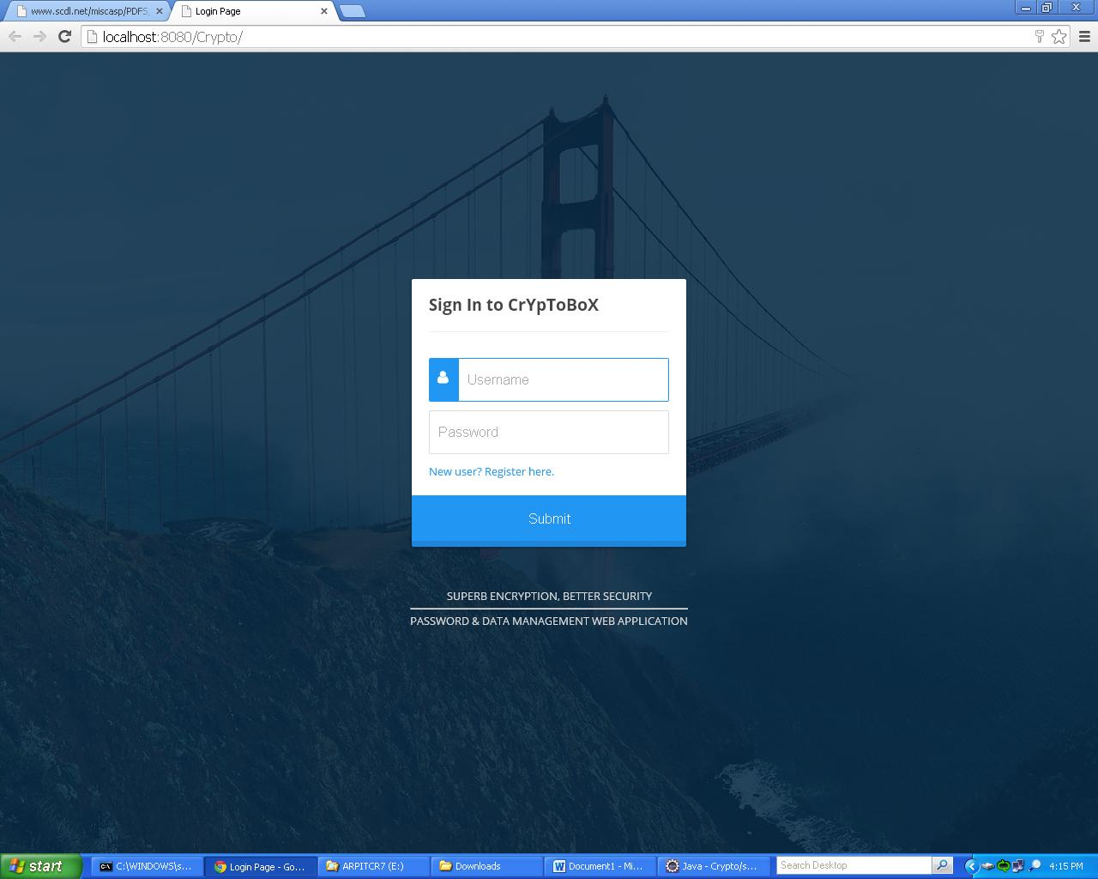

Sign up page for new users.

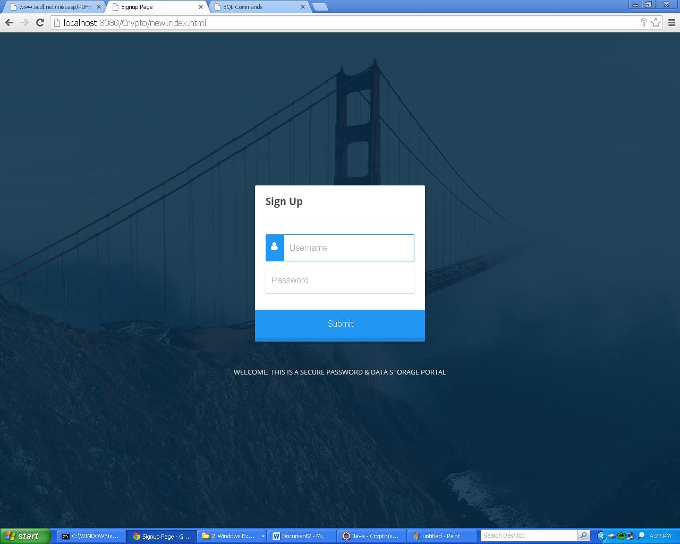

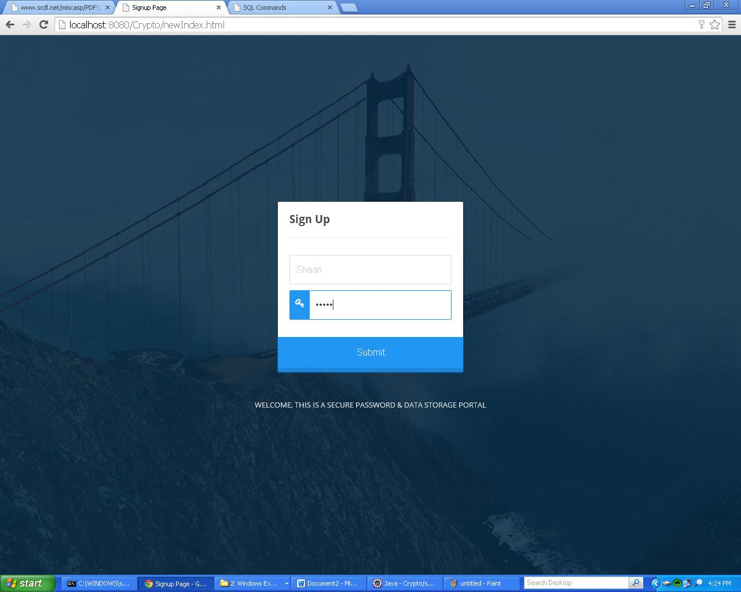

Account Password encrypted and stored in the database

PS. Password was hello, username was Shaan

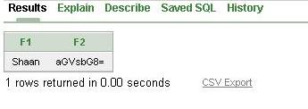

Data entry Form design

Data is entered via this form and inserted into database.

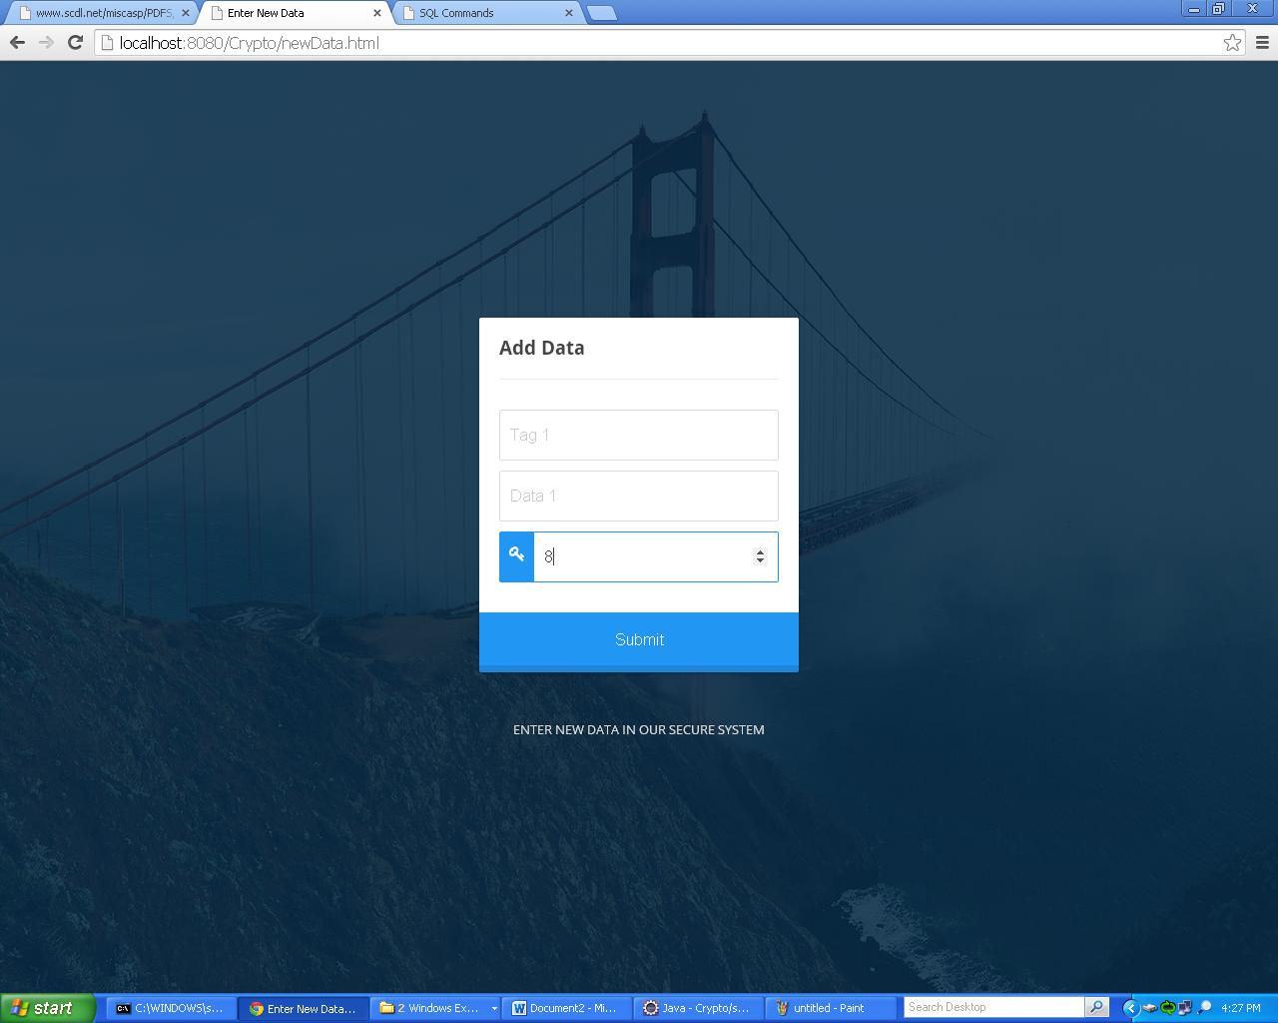

The entered data was

Tag: Tag 1

Data: Data 1

Key: 8

It’s stored in the database as follows

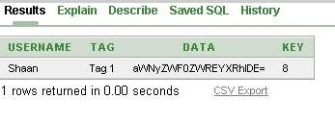

Display table design

Displays the user data

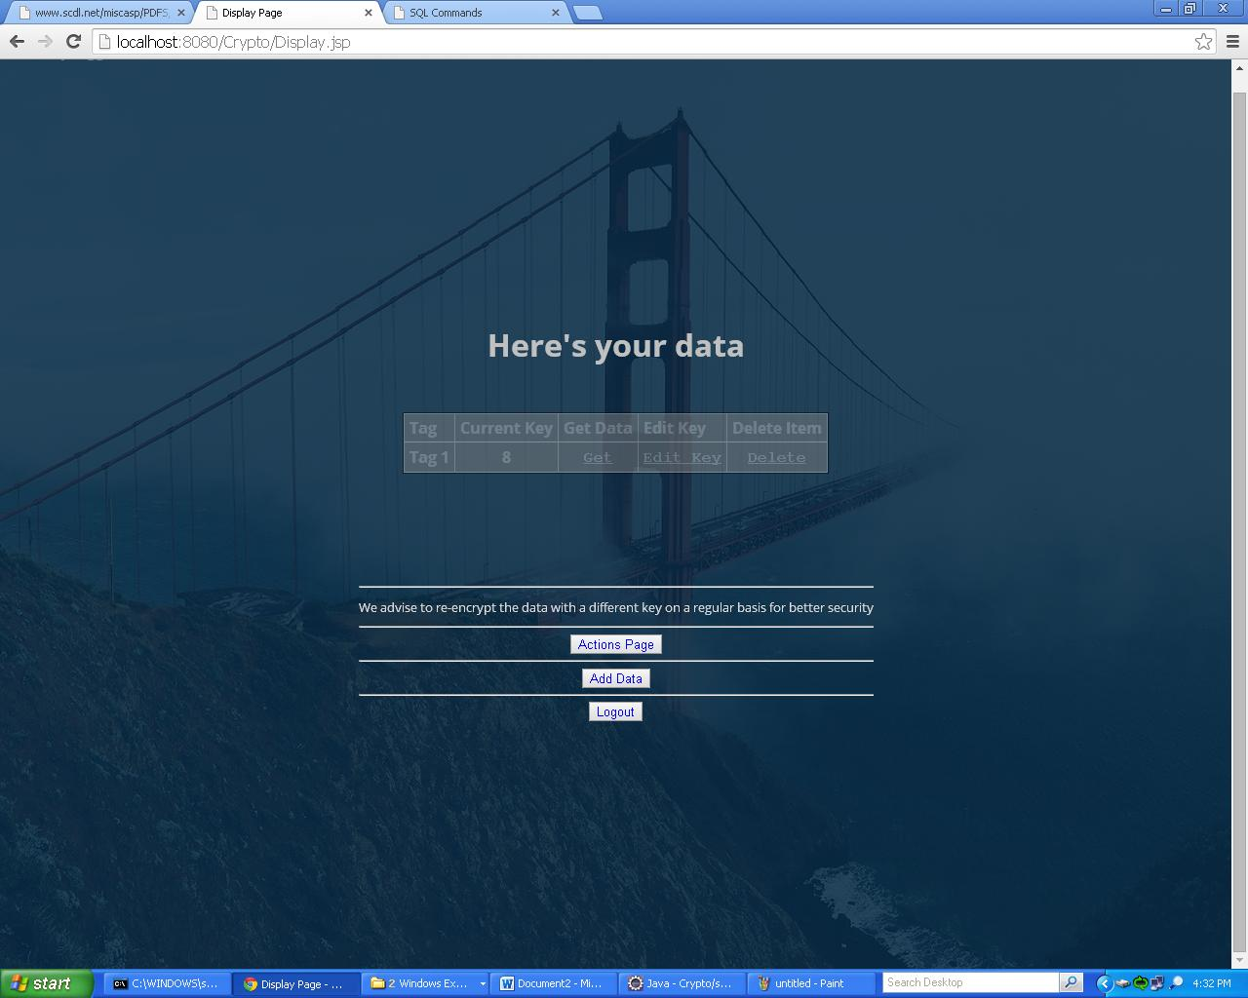

Clicking on ‘Get’ link decrypts and displays the data.



Clicking on ‘Edit Key’ link on Display page will provide an option to re-encrypt the data with a different key. Note that higher key values will result in better security, however slower conversion speed.

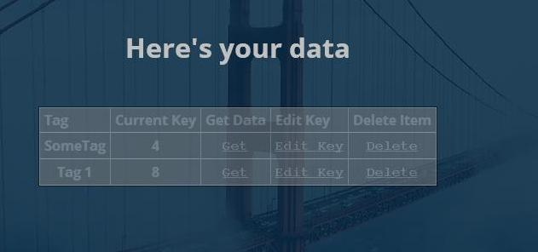

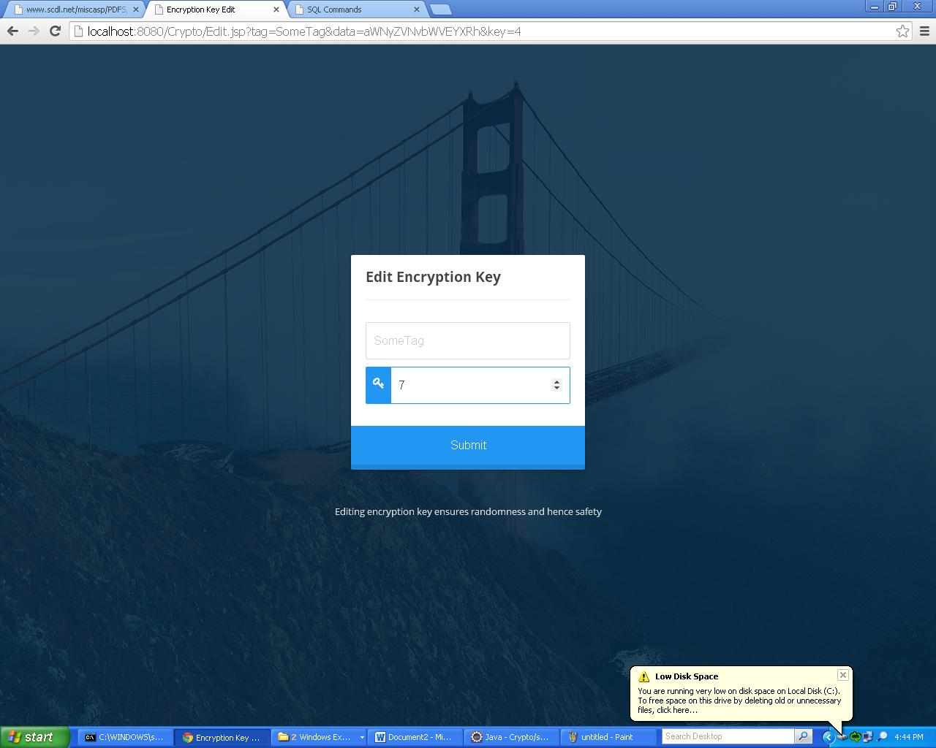

We changed the key from 4 to 7.

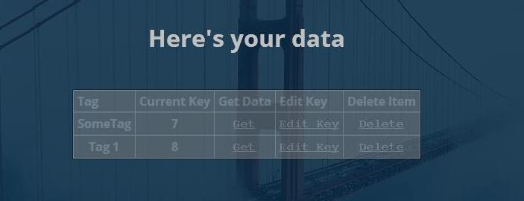

Actions Page button leads to the following actions page which provides options to view, add data or to remove the profile.

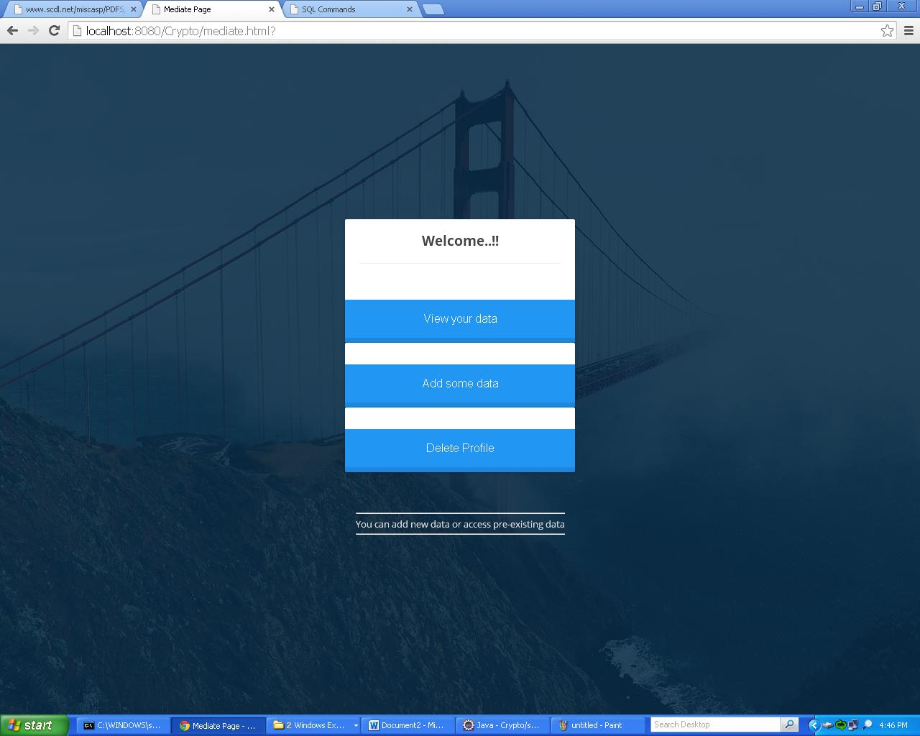

Logout button on Display page logs out the current user.

